Q1: For the N.N shown below, find the outputs applying

1. Threshold A.F; b) Sigmoid A.F

Knowing that x= [1 2 3]

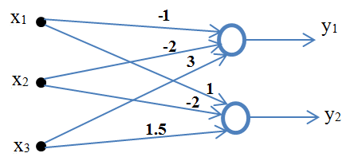

Q2: Implement the followings by N.N, using Threshold A.F for all.

a) EX- OR

b) EX-NOR

c)The following table without bais

|  |  |  |
| --- | --- | --- |
| x1 | x2 | o/p |
| 0 | 0 | 0 |
| 1 | 0 | 1 |
| 0 | 1 | 0 |
| 1 | 1 | 1 |